EXP NO.: 1
DATE: 16/07/2008

FAMILIARISATION OF COMPONENTS

PROBLEM DEFINITION
To familiarize the given components.

PROCEDURE
The components which were analyzed are
1. DC power supply
2. Multimeter
3. Function generator
4. CRO
5. Resistor color coding
6. Bread Board

THEORETICAL BACKGROUND

Multimeter
A multimeter is used to make various electrical measurements, such as AC and DC voltage, AC and DC current, and resistance. It is called a multimeter because it combines the functions of a voltmeter, ammeter, and ohmmeter. Multimeters may also have other functions, such as diode and continuity tests.

DC Power supply
The DC source of supply required for devices such as zener diode, FET’s,SCR’s,UJT’s,gas tubes etc should not vary in output due to
(1) variation of the load
(2) variation of ac input to the source of the dc supply.

This kind of supplied source is known as Regulated power supply.
A majority of active components need the application of dc on various electrodes or terminals,like emitter circuit of a bipolar junction transistor needs forward bias ,the collector of the same component needs reverse bias dc, the anodes of the vacuum tubes use high voltage +ve dc potential ,the control guides need a negative potential etc.. Similar biasing is involved in the zener diode; FET’s, SCR’s, UJT’s, gas tubes etc.

Unregulated DC power supply:
The block wise placement of the components can be studied by knowing the functioning of the circuit that can be reviewed as per the block. The transformer used here is a step-down one for a low voltage output, but a step-up transformer is used if the output required is high. the transformer is used for providing the required magnitude of the dc output voltage.
It also consists of a rectifier circuit consisting of diodes which converts the output of the transformer circuit into a pulsating dc. the pulsating dc consists of both the dc and ac components with a ripple factor of .48 for full wave rectifier output. So it is necessary that we should eliminate the ac components. The filter circuits here helps to smoothen the output by minimizing the ripples in the supply. This is done by means of capacitors and inductors in the circuit.

Basic Operation of the Function Generator
With the controls set as indicated, the three waveforms shown on the right of the panel are available at the output socket depending on which selector buttons are engaged. The frequency will be approximately 5kHz.
The FREQUENCY VERNIER control enables the frequency to be set from less than 100Hz to greater than12kHz on this range. This is displayed on the digital readout when the COUNTER SOURCE SWITCH is in the up position.
Output amplitude is set by the AMPLITUDE control and the ATTENUATOR switches from approx. 30mV to 20V p-p o/c. A sync pulse is available at the SYNC socket. Phase relationships are shown in figure
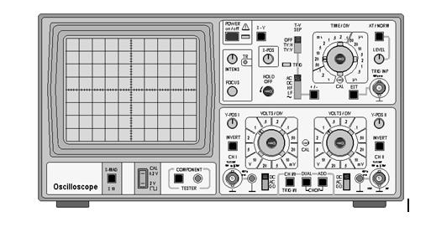
Figure .Function Generator Output Capabilities.
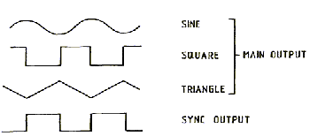
Phase Relationships of Function Generator Outputs and Sync(ronisation) Output.
Cathode Ray Oscilloscope
CRO allows a visual picture of the time relationship of any waveform to be obtained as well as permitting the measurement of amplitude, frequency, phase etc. Basically, the CRO consists of a cathode ray tube in which a beam of electrons is made to strike the face of the tube and produce a visual spot, by phosphorescence. The intensity and focus controls can be adjusted to give a fine, bright spot. The beam may be deflected horizontally in a repetitive linear manner by means of the 'timebase'. The spot is made to move from left to right at a speed depending on the setting of the TIME/DIV control; when it reaches the end of its traverse it is immediately brought back to its starting point at the left-hand side of the screen. During this 'retrace', or 'flyback' time, the brightness of the spot is automatically 'blanked' so that the retrace cannot be observed. This procedure is repeated continually so that a thin bright horizontal trace is observed (X-axis).

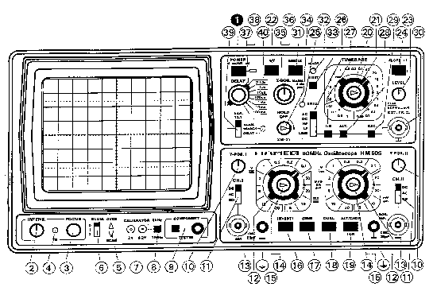

The spot can also be made to deflect in a vertical direction (Y-axis) so that the application of a time-varying signal waveform to the Y-amplifiers will result in a visual picture of the waveform. The Y-amplifier is used to drive the spot in a vertical direction, the input being the signal that is to be observed. Amplification may be varied to allow for different amplitudes of input signal and the traces may be shifted vertically with the Y-POS control. The input to the Y-amplifier can be AC coupled to remove unwanted DC components from the signal; alternatively DC coupling can be selected.
In a dual trace CRO one electron beam is shared between two Y-amplifiers by 'time division multiplexing' the beam between the output of the respective amplifiers. This can be done in two ways; - CHOP, where the beam is swapped at very high frequency between the two traces, and ALTernate, where the beam makes a complete trace before being used to display the other trace on the subsequent timebase sweep. CHOP is the only way to reliably compare phase between traces on such a CRO.
The timebase will run freely to produce a trace, but if it is required to observe a repetitive waveform it is necessary to 'lock', or 'synchronize' the start time of the timebase to a particular point on the input waveform. This is achieved with the aid of the TRIGGER, LEVEL and SLOPE +/- controls.
In order to prevent damage to the CRO it is necessary to avoid the use of extreme brightness for prolonged periods otherwise the phosphor on the tube face may be permanently burned. Therefore it is a wise precaution to reduce the intensity when not using the CRO for prolonged periods, or if the timebase is not functioning; - e.g. when in X-Y mode.
In order to obtain a steady picture of most types of input signal follow these basic instructions: -
1. Obtain a trace; - start with all control knobs pushed in and set to CAL or centred as appropriate, all pushbuttons released, all slide switches to top position. Push POWER in, wait for traces to appear and then adjust X-POS and Y-POS to centre trace.
2. Select dual-trace, chop mode by ensuring that DUAL and CHOP pushbuttons are depressed. Connect the input signal to the chosen Y-input(s) and select DC or AC coupling using DC-AC-GD slide switch.
3. Select appropriate trigger source, using (TRIG) I/II pushbutton (out for channel I, in for channel II as source).
4. Select TIME/DIV switch (calibrated in s, ms or µs per 1 cm horizontal screen division) and adjust switched Y-gain controls (calibrated in V or mV per 1 cm vertical screen division), as appropriate to achieve desired display.
5. If trace is not stable, pull out and rotate LEVEL control as required. If this fails, it will be necessary to begin experimenting with the operation of the other trigger controls (refer to manual)!
Resistor
A resisitor is a passive circuit element whose primary function is to introduce electrical resistance into an electrical circuit.the important characteristics of a resistor are
1. Resistance value
2. Power dissipation
3. Frequency characteristics
4. Stability with age and temperature
5. Mounting arrangement and relative cost

Value (first two rings):
Colour | Value
Black | 0
Brown | 1
Red | 2
Orange | 3
Yellow | 4
Green | 5
Blue | 6
Magenta | 7
Gray | 8
White | 9
Multiplying factor (third ring):
Colour | Factor
Silver | 0.01 (1⁻²)
Gold | 0.1 (1⁻¹)
Black | 1 (1⁰)

Capacitor
Capacitor is an electronic device that can store energy in the form of electrostatic field. in the most basic form, it consist of two parallel conducting plates separated by an insulating medium called dielectric. to achieve any reasonable value of capacitance the area of plate must be large. the relative permittivity of the dielectric must be high and the dielectric thickness should be small.
Diode
Semiconductors are crystals that, in their pure state, are resistive (that is, their electrical properties lie between those of conductors and insulators) -- but when the proper impurities are added (this process is called doping) in trace amounts (often measured in parts per billion), display interesting and useful properties. The first electronic device to be introduced is called the diode. There are two kinds of diodes: a diode, which forms an electrical barrier at the interface between and layers, and a Schottky diode, whose barrier is formed between metal and regions.

Bread board
A solderless bread board is a multi purpose board with 128 groups and 5 connected terminals. in each we can insert pin of components. the inserted components is caught in between two plates with spring action. The 128 groups of terminals are arranged on upper side and lower side of the bread board, in two set sof 64 each. each group on both sides marked with 1-62 except the first 2 groups.it means,the numbering starts from 3rd group and first two groups are not numbered.

CONCLUSION
The components being used in the solid state electronics lab viz. the multimeter, function generator, CRO, resister, capacitor bread board were observed and studied.

EXP NO: 2

DATE: 23/07/2008

DIODE CHARACTERISTICS

INTRODUCTION:
The first electronic device to be introduced is called as the diode. It is the simplest semiconductor device but plays a very important role in electronics system. The ideal diode has two terminals – one is the positive terminal and the other is the negative terminal. The current through a diode flows from positive to negative termeinal. Ideally the diode will conduct current only in one direction.

PROBLEM DEFINITION:
To study and plot
- The forward characteristics of Silicon and Germanium diode.
- The reverse characteristics of Zener Diode.

THEORETICAL BACKGROUND:
When a P-N junction is created, a potential barrier is created by diffusion of majority charge carriers. The diode will not conduct until the applied voltage overcomes the barrier. As a result there is a high forward voltage. In the reverse biased condition, the depletion layer widens and prevents majority carriers from crossing the junction. But there will be a small minority current (of the order of μA). Using this Zener diodes is designed which have a high breakdown voltage and are used as constant voltage sources. There are two mechanism of breakdown
- Avalanche breakdown.
- Zener breakdown.
Zener breakdown:
Zener diodes are used in voltage regulator circuits. Zener breakdown occurs at reverse voltage of about 6V or a little less. When reverse bias is applied across the diode the depletion region widens. Barrier potential equals to that of applied potential. When barrier potential increases, the field across the junction is also increased. When the diode is heavily doped, the depletion region is very narrow. Because of this, the electric field across the narrow depletion region is very intense. When the field strength increases approximately 300000V/cm, the field is intense enough to pull electrons out of the valence orbits. These electron-hole pairs created by breaking of bonds move across the junction under the influence of the electric field. This constitutes a large and sudden increase in reverse current. This is called Zener breakdown.
The breakdown current be limited to safe values by connecting external resistance. The voltage across the diode does not change with reverse current. By varying doping levels, Zener breakdown voltage from 2V to 200V can be obtained.

Avalanche breakdown:
In some diodes, even at a reverse voltage of around 6V, the breakdown does not occur (this is due to doping concentration). If the reverse voltage is further increased, the minority carrier gets more acceleration. These minority carriers, constituting reverse saturation current, get accelerated and collide with other valence electron and create more electron hole pairs by collision. Thus there is a sudden increase in reverse current at a particular reverse voltage. This reverse voltage is called Avalanche breakdown.
In reverse bias, leakage current is caused by the thermal rapture of the covalent bonds which always results in the generation of the electron-hole pairs. Leakage current is a function of temperature. Silicon devices have only about 0.001 of the leakage current (at 20ºC) that we would expect from a Ge device at the same temperature.
In avalanche breakdown carriers are generated so quickly and in such large numbers that there is truly an apparent avalanche or self sustained multiplication process. This happens when the thermally generated electron hole pairs strike the other charge carriers with strong energy. Any resistance connected externally limits the current and the junction is said to be in breakdown voltage controlled in the range 6V to 500V.

Difference between Zener and Avalanche breakdown:
Zener breakdown | Avalanche breakdown
Occurs around less then 6V | Occurs at greater than 6V
Zener breakdown voltage reduces with temperature | Avalanche breakdown voltage increases with temperature

COMPONENTS REQUIRED:
SL.NO. | INSTRUMENT | SPECIFICATION | QUANTITY
1 | Silicon diode | IN 4001 | 1
2 | Rheostat | 330Ω, 1-1A | 1
3 | Germanium diode | 0A 79 | 1
4 | Zener diode | SZ 6.8V | 1
5 | Bread board |  | 1
6 | Voltmeter | 0-1V | 1
 |  | 0-100V | 1
7 | DC power supply | 0 – 30 V Dual
8 | Ammeter | 0-10mA | 1
 |  | 0-100mA | 1
9 | Resistor | 100 Ω | 1

PROCEDURE:
- Identify the anode and cathode of the diode using the multimeter,set up the circuit on the bread board as in the diagram.
- Switch on the power supplies and vary the rheostat,so that the voltmeter reading vary from 0 to 1 V in steps of .1 V. Note down the readings of voltmeter and ammeter for each settings of the rheostat. Tabulate the readings and plot the graph for the forward bias conditions.
- Repeat step 2 using Ge diode.Plot the forward characteristics.
- For Zener reverse characteristics connect the diode according to the circuit.
- Vary the rheostat and note the ammeter , voltmeter reading. Plot the graph and find the Zener breakdown voltage.

CIRCUIT DIAGRAM:

FORWARD CHARACTERISTICS OF SILICON

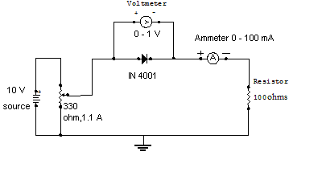

FORWARD CHARACTERISTICS OF GERMANIUM

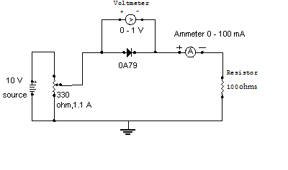
REVERSE CHARACTERISTICS OF ZENER DIODE

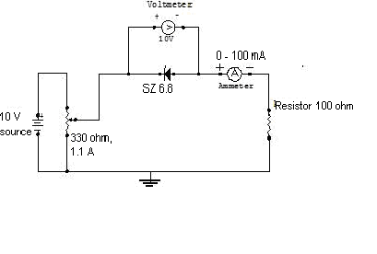

OBSERVATION TABLE

Forward characteristics of Silicon diode:

SL.NO. | VOLTAGE(V) | CURRENT(I) (mA)
1 | 0.1 | 0.1
2 | 0.2 | 0.2
3 | 0.3 | 0.25
4 | 0.4 | 0.3
5 | 0.5 | 0.6
6 | 0.6 | 4.0
7 | 0.64 | 9.0

Forward characteristics of Germanium diode:

SL.NO. | VOLTAGE(V) | CURRENT(I) (mA)
1 | 0.1 | 0.1
2 | 0.2 | 0.3
3 | 0.3 | 0.8
4 | 0.4 | 1.4
5 | 0.5 | 2.2
6 | 0.6 | 3.2
7 | 0.7 | 4.1
8 | 0.8 | 4.4
9 | 0.9 | 5.6

Reverse characteristics of Zener diode:

SL.NO. | VOLTAGE(V) | CURRENT(I) (mA)
1 | 1.0 | 0.0
2 | 2.0 | 0.0
3 | 3.0 | 0.0
4 | 4.0 | 0.0
5 | 5.0 | 0.0
6 | 6.0 | 0.0
7 | 6.4 | 1.0
8 | 6.6 | 2.0
9 | 6.8 | 8.0
10 | 6.9 | 20

CALCULATION
Static resistance of Si diode = V / I
= 0.64/9× 10־³
=71.11 Ω
Dynamic resistance of Si diode = ΔV/ ΔI
= [(0.64-0.6)] / [(9-4) ×10־³]
= 8 Ω
Static resistance of Ge diode = V / I
= 0.5/2.2× 10־³
= 227.27 Ω
Dynamic resistance of Ge diode = ΔV/ ΔI
= [(0.6-0.4)] / [(3.2-1.4) ×10־³]
= 111.11 Ω

Static resistance of zener diode = V / I
= 6.8 / 8 × 10־³
= 850 Ω
Dynamic resistance of zener diode = ΔV / ΔI
= (6.9-6.4) / [(20-1) × 10־³]
=26.31Ω

RESULT

The forward and reverse characteristics of given diode has been studied and plotted.

Si diode forward biased at 0.60 V.
Static forward resistance =71.11 Ω
Dynamic forward resistance= 16.67 Ω

Ge diode forward biased at 0.29 V.
Ge Static forward resistance =227.27 Ω
Dynamic forward resistance= 111.11 Ω

Zener diode reverse biased at 6.5 V.
Static reverse resistance =850 Ω
Dynamic reverse resistance= 26.31 Ω

INFERENCE

- Cut in voltage of Si is more than that of Ge.
- As output voltage of Zener diode remains a constant with large variation in current, it can be used as voltage regulator.
- After cut in voltage, change in current is more than change in voltage.
- Forward resistance of the diode is less than reverse resistance.

